a)

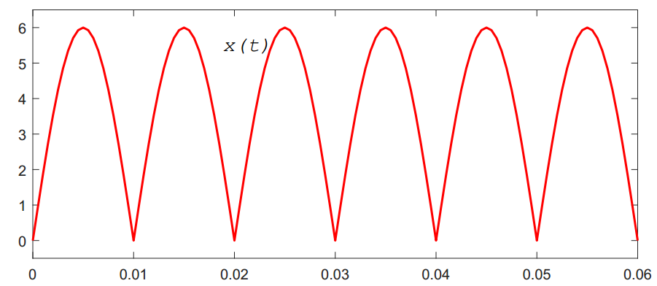

From the figure: $T_{0}=0.01 (s)$.

$$P_{x}=\frac{1}{T_{0}}\int_{t_{0}}^{t_{0}+T_{0}}{{\left|x\left(t\right)\right|}^{2}dt}=\frac{1}{0.01}\int_{0}^{0.01}{{\left|6\sin{100πt}\right|}^{2}dt}=18$$

b)

Sampling time: $T_{s}=1/{f_{s}}=1/{20}=0.05 (s)$

Sampled signal: $x\left[n\right]=x\left(nT_{s}\right)=5\cos\left(10π×0.05n\right)=5\cos\left(0.5πn\right)$

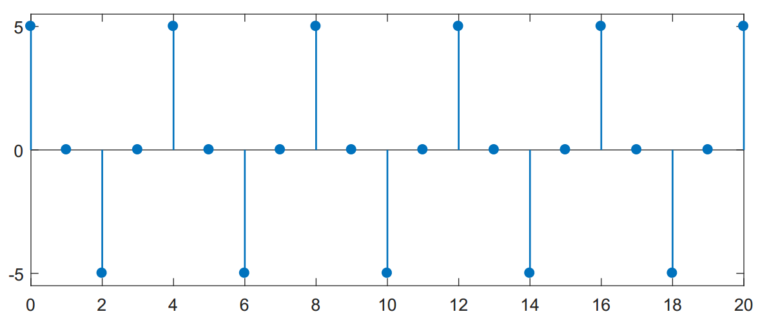

$$P_{x}=\frac{1}{N}\sum_{n=0}^{N-1}{{\left|x\left[n\right]\right|}^{2}}=\frac{1}{21}\sum_{n=0}^{20}{{\left|5\cos\left(0.5πn\right)\right|}^{2}}=\frac{275}{21}$$

Given that:

a)

1. Check for linearity:

$$Let: \left\{\begin{aligned}x_{1}\underset{→}{S}y_{1}=x_{1}\left(t-2\right)+x_{1}(2-t) \\ x_{2}\underset{→}{S}y_{2}=x_{2}\left(t-2\right)+x_{2}(2-t)\end{aligned}\right.$$

$$→a_{1}y_{1}+a_{2}y_{2}=a_{1}\left(x_{1}\left(t-2\right)+x_{1}\left(2-t\right)\right)+a_{2}\left(x_{2}\left(t-2\right)+x_{2}\left(2-t\right)\right) (1)$$

Let: $x=a_{1}x_{1}+a_{2}x_{2} \underset{→}{S}y$

$$→y=a_{1}x_{1}\left(t-2\right)+a_{2}x_{2}\left(t-2\right)+a_{1}x_{1}\left(2-t\right)+a_{2}x_{2} (2-t) (2)$$

From $(1)$ and $\left(2\right)$, $a_{1}y_{1}+a_{2}y_{2}=S\left\{a_{1}x_{1}+a_{2}x_{2}\right\}$, the system is linear.

2. Check for time invariant:

Let: $x(t)\underset{→}{S}y=x\left(t-2\right)+x(2-t)$

$→y\left(t-T\right)=x\left(t-T-2\right)+x(2-t+T)$ $(1)$ (delay the ouput).

Let: $x_{T}\left(t\right)=x\left(t-T\right)\underset{→}{S}y_{T}$

$$→y_{T}=x_{T}\left(t-2\right)+x_{T}\left(2-t\right)=x\left(t-T-2\right)+ x\left(-t-T-2\right)(2)$$

Since, $\left(1\right)≠(2)$, therefore, the system is time variant.

b)

Assume that $\left|x\left(t\right)\right|≤M, M$ is finite for all $t$.

We have: $\left|y\left(t\right)\right|=\left|x\left(t-2\right)+x(2-t)\right|≤\left|x\left(t-2\right)\right|+\left|x\left(2-t\right)\right|≤M+M=2M$

$$→\left|y\left(t\right)\right|≤2M$$

Therefore, with bounded input, the output will be bounded, which leads to the system is BIBO system.

Given that: $h\left[n\right]=\left[2, -1, 0, 2\right]$

$$y\left[n\right]=x\left[n\right]*h\left[n\right]=\sum_{k=-∞}^{+∞}{x\left[n-k\right]h\left[k\right]}=\sum_{k=0}^{3}{x\left[n-k\right]h\left[k\right]}$$

$$=x\left[n\right]h\left[0\right]+x\left[n-1\right]h\left[1\right]+x\left[n-2\right]h\left[2\right]+x\left[n-3\right]h\left[3\right]$$

$$=2x\left[n\right]-x\left[n-1\right]+2x\left[n-3\right]$$

c) Given that: $x\left[n\right]=\left[2, 1, 0, 1, 3\right]$

$$+ y\left[0\right]=2x\left[0\right]-x\left[-1\right]+2x\left[-3\right]=2×2-0+2×0=4$$

$$+ y\left[1\right]=2x\left[1\right]-x\left[0\right]+2x\left[-2\right]=2×1-2+2×0=0$$

$$+ y\left[2\right]=2x\left[2\right]-x\left[1\right]+2x\left[-1\right]=2×0-1+2×0=-1$$

$$+ y\left[3\right]=2x\left[3\right]-x\left[2\right]+2x\left[0\right]=2×1-0+2×2=6$$

$$+ y\left[4\right]=2x\left[4\right]-x\left[3\right]+2x\left[1\right]=2×3-1+2×1=7$$

$$+ y\left[5\right]=2x\left[5\right]-x\left[4\right]+2x\left[2\right]=2×0-3+2×0=-3$$

$$+ y\left[6\right]=2x\left[6\right]-x\left[5\right]+2x\left[3\right]=2×0-0+2×1=2$$

$$+ y\left[7\right]=2x\left[7\right]-x\left[6\right]+2x\left[4\right]=2×0-0+2×3=6$$

Therefore, $y\left[n\right]=\left[4, 0, -1, 6, 7, -3, 2, 6\right]$

Given that: $h\left(t\right)=e^{-t/2}u(t)$

a)

For $t<0$, $h(t)$ and $x(t)$ does not overlap.

For $t≥0$:

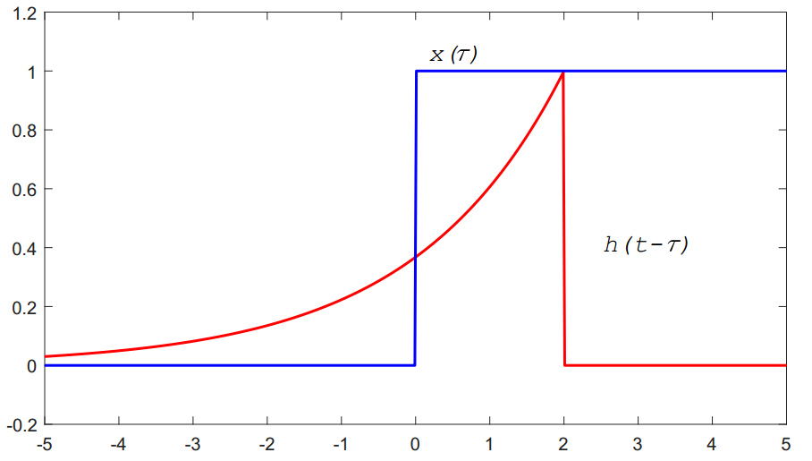

$$y\left(t\right)=\int_{-∞}^{+∞}{x\left(τ\right)h\left(t-τ\right)dτ}=\int_{0}^{t}{1.e^{-{\left(t-τ\right)}/2}dτ}=e^{-t/2}\int_{0}^{t}{e^{-τ/2}dτ}=2e^{-t/2}\left(1-e^{-t/2}\right)$$

Thus,

$$y_{1}\left(t\right)=y\left(t\right)=\left\{\begin{aligned}0 , t<0 \\ 2e^{-t/2}\left(1-e^{-t/2}\right), t≥0\end{aligned}\right.$$

b)

We have: $x_{2}\left(t\right)=2u\left(t\right)-2u\left(t-3\right)=2x_{1}\left(t\right)-2x_{1}\left(t-3\right)$

By the properties of LTI system, the output $y_{2}(t)$ is given by:

$$y_{2}\left(t\right)=2y_{1}\left(t\right)-2y_{1}\left(t-3\right)$$

$$=\left\{\begin{aligned}0 , t<0 \\ 4e^{-t/2}\left(1-e^{-t/2}\right) ,0≤t<3 \\ 4e^{-t/2}\left(1-e^{-t/2}\right)-4e^{-{\left(t-3\right)}/2}\left(1-e^{-{\left(t-3\right)}/2}\right), t≥3\end{aligned}\right.$$